Answer the Following Questions:
Question No. (1) (6 marks)
1.1 What are the four building blocks of a microprocessor system?

Ans. Input unit, output unit, microprocessing unit, and memory unit.

1.2 Is the 8088 an 8-bit or a16-bit microprocessor?

Ans. 16-bit.

1.3 Mention the address capability of 8086 and also show its memory map.

Ans. 8086, via its 20-bit address bus, can address 220 = 1,048,576 or 1 MB of different memory locations. Thus the memory space of 8086 can be thought of as consisting of 1,048,576 bytes or 524,288 words.
The memory map of 8086 is shown in the Figure, where the whole memory space starting from 00000 H to FFFFF H is divided into 16 blocks—each one consisting of 64KB. This division is arbitrary but at the same time a convenient one—because the most significant hex digit increases by 1 with each additional block. Thus, 30000 H memory location is 65,536 bytes higher in memory than the memory location 20000 H. The lower and upper ends of the memory map are shown separately—earmarking some spaces as reserved and some as ‘dedicated’. The reserved locations are meant for future hardware and software needs while the dedicated locations are used for processing of specific system interrupts and reset functions.

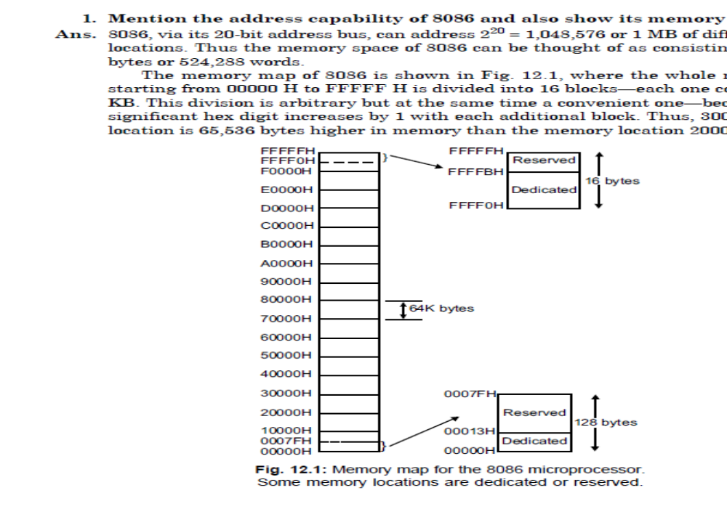
Memory map for 8086 microprocessor

1.4 Name the two processing units of the 8088 microprocessor.

Ans. Bus interface unit and execution unit.

1.5 Which processing unit for the 8088 microprocessor is the interface to the outside world?
Ans. BIU.

1.6 What are the length of the 8086’s address bus and data bus?

Ans. 20 bits; 16 bits.

1.7 What is the purpose of a software model for a microprocessor?

Ans. Aid to the assembly language programmer for understanding a microprocessor's software operation.

1.8 Is the memory in the 8088 microprocessor organized as byte, word or doubleword?

Ans. Bytes.

1.9 Which of the 8088’s internal registers are used for memory segmentation?

Ans. Code segment (CS) register, stack segment (SS) register, data segment (DS) register, and extra segment (ES) register.

1.10 What happens to the value in IP each time 8088 microprocessor completes an instruction?

Ans. IP is incremented such that it points to the next sequential word of instruction code.

1.11 Make a list of the general purpose registers?

Ans. Accumulator (AX) register, base (BX) register, count (CX) register, and data (DX) register.

1.12 Name the two pointer registers.

Ans. Base pointer (BP) and stack pointer (SP).

Question No. (2) (6 marks)
2.1 What do the following MOV instructions accomplish?
(a) MOV AX, BX
(b) MOV BX, AX
(c) MOV BL, CH
(b) MOV SP, BP
(e) MOV AX, CS

Ans.
(a) MOV AX, BX ; copy BX into AX
(b) MOV BX, AX ; copy AX into BX
(c) MOV BL, CH ; copy CH into BL
(b) MOV SP, BP ; copy BP into SP
(e) MOV AX, CS ; copy CS into AX

2.2 List the 8-bit registers used for register addressing.

Ans. AL, AH, BL, BH, CL, CH, DL, and DH

2.3 What is wrong with the MOV BL, CX instruction?

Ans. You may not specify mixed register sizes.

2.4 Select an instruction for each of the following tasks:
(a) copy BX into DX
(b) copy BL into CL
(c) copy SI into BX
(d) copy DS into AX
(e) copy AL into AH

Ans.
(a) MOV DX, BX
(b) MOV CL, BL
(c) MOV BX, SI
(d) MOV AX, DS
(e) MOV AH, AL

2.5 Select an instruction for each of the following tasks:
(a) move a 12H into AL
(b) move a 123AH into AX
(c) move a CDH into CL
(d) move a 1000H into SI
(e) move a 12A2H into BX

Ans.
(a) MOV AL, 12H
(b) MOV AX, 123AH
(c) MOV CL ,CDH Find the memory address of the next instruction executed by the microprocessor, when operated
in the real mode, for the following CS:IP combinations:
(d) MOV SI, 1000H
(e) MOV BX, 12A2H

2.6 Suppose that DS=0200H, BX=0300H, and DI=400H. Determine the memory address accessed by each of the following instructions, assuming real mode operation:
(a) MOV AL, [1234H]
(b) MOV AX, [BX]
(c) MOV [DI], AL

Ans.
(a) DSx10+1234H=2000H+1234H=3234H
(b) DSx10+300H=2000H+300H=2300H
(c) DSx10+400H=2000H+400H=2400H

2.7 What is wrong with a MOV [BX], [DI] instruction?

Ans. Memory-to memory moves are not allowed.

2.8 Suppose that DS=1000H, SS=2000H, BP=1000H, and DI= 100H. Determine the memory address accessed by each of the following, assuming real mode operation:
(a) MOV AL, [BP+DI]
(b) MOV CX, [DI]
(c) MOV DX, [BP]

Ans.
(a) SSx10+BP+DI=20000H+1000H+100H=21100H
(b) DSx10+100H=10000H+100H=10100H
(c) SSx10+BP=20000H+1000H=21000H

2.9 Suppose that DS=1200H, BX=0100H, and SI=0250H. Determine the address accessed by each of the following instructions assuming real mode operation:
(a) MOV [1000H], DL
(b) MOV [SI+1000H], AX
(c) MOV DL, [BX+100H]

Ans.
(a) DSx10+1000H=12000H+1000H=13000H
(b) DSx10+SI+1000H=12000H+250H+1000H=13250H
(c) DSx10+BX+100H=12000H+100H+100H=12000H

2.10 Suppose that DS=1300H, SS=1400H, BP=I500H, and SI=0100H. Determine the address accessed by each of the following instructions, assuming real mode operation:
(a) MOV AX, [BP+200H]
(b) MOV AL, [BP+SI-200H]
(c) MOV AL, [SI-0100H]

Ans.
(a) SSx10+BP+200H=14000H+1500H+200H=15700H
(b) SSx10+BP+SI-200H=14000H +1500H +100H-200H=15400H
(c) DSx10+SI-200=13000H+100H-200H=12F00H

2.11 Calculate the value of each of the physical addresses that follows. Assume all numbers are hexadecimal numbers.
(a) 1000:1234
(b) 0100:ABCD
(c) A200:12CF
(d) B2C0:FA12

Ans.
(a) 1000x10+1234H=11234H
(b) 0100x10+ABCDH=0BBCDH
(c) A200x10+12CFH=A32CFH
(d) B2C0x10+FA12H=C2612H

2.12 Find the unknown value for each of the following physical address. Assume all numbers are hexadecimal numbers.
(a) A000:???? =A0123
(b) ????:14DA=235DA
(c) D765:???? =DABC0
(d) ????:CD21=32D21

Ans.
(a) A000x10+???? = A0123 ????=0123H
(b) ????x10+14DA = 235DA ????=2210H
(c) D765x10+???? = DABC0 ????=3570H
(d) ????x10+CD21=32D21 ???? = 2600H

2.13 Find the memory address of the next instruction executed by the microprocessor, when operated in the real mode, for the following CS:IP combinations:
(a) CS = 1000H and IP = 2000H
(b) CS = 2000H and IP = 1000H
(c) CS = 2300H and IP = 1A00H
(d) CS =1A00H and IP =B000H
(e) CS = 3456H and IP = ABCDH

Ans.
(a) CSx10+IP= 10000H + 2000H=12000H
(b) CSx10+IP= 20000H + 1000H=21000H
(c) CSx10+IP= 23000H + 1A00H=24A00H
(d) CSx10+IP= 1A000H + B000H=25000H
(e) CSx10+IP= 34560H + ABCDH=3F120H

2.14 If the base pointer (BP) addresses memory, the ________ segment contains the data.

Ans.
If the base pointer (BP) addresses memory, the STACK segment contains the data.

2.15 Determine the memory location addressed by the following 8086/8088 register combinations:
(a) DS =1000H and DI =2000H
(b) DS = 2000H and SI = 1002H
(c) SS = 2300H and BP =3200H
(d) DS =A000H and BX =1000H
(e) SS =2900H and SP = 3A00H

Ans.
(a) DSx10+DI =10000H +2000H=12000H
(b) DS x10+SI= 20000H +1002H=21002H
(c) SS x10+BP= 23000H +3200H=26200H
(d) DSx10+BX =A0000H +1000H=A1000H
(e) SS x10+SP=29000H + 3A00H=2CA00H

2.16 What is the function of the stack?

Ans.
The stack is the area of memory used to temporarily store information (parameters) to be passed to subroutines and other information such as the contents of IP and CS that is needed to return from a called subroutine to the main part of the program.

Question No. (3) (8 marks)
3.1 The PUSH and POP instructions always transfer a_______________-bit number between the stack and a register or memory location in the 8086 microprocessor.

Ans.
The PUSH and POP instructions always transfer a 16-bit number between the stack and a register or memory location in the 8086 microprocessor.

3.2 Describe the operation of each of the following instructions:
(a) PUSH AX
(b) POP SI
(c) PUSH [BX]
(d) POP DS

Ans.
(a) AX is copied to the stack.
(b) A 16-bit number is retrieved from the stack and placed into SI.
(c) The word contents of the data segment memory location addressed by BX is pushed onto the stack.
(d) A word is retrieved from the stack and placed into DS.

3.3 What values appear in SP and SS if the stack is addressed at memory location 02200H?

Ans.
One possibility is 200H in both registers.

3.4 Describe how the LDS BX, NUMB instruction operates.

Ans.
This instruction loads DS and BX with 32-bit number stored at memory location NUMB.

3.5 Develop a sequence of instructions that move the contents of data segment memory locations NUMB and NUMB+1 into BX, DX, and SI.

Ans.
MOV BX, NUMB
MOV DX, BX
MOV SI, DX

3.6 Explain how the XLAT instruction transforms the contents of the AL register.

Ans.
The XLAT instruction passes the contents of AL to the contents of BX to form a data segment offset address that accesses a memory location whose content is then copied into AL.

3.7 Explain what the IN AL, 12H instruction accomplishes.

Ans.
The IN AL, 12 H instruction inputs a byte of data from I/O port 0012H into AL.

3.8 Develop a sequence of instructions that exchange the contents of AX with BX, CX with DX, and SI with DI.

Ans.
XCHG AX, BX
XCHG CX, DX
XCHG SI, DI

3.9 Develop a short sequence of instructions that add AX, BX, CX, DX, and SP. Save the sum in the DI register.

Ans.
ADD AX,BX
ADD AX,CX
ADD AX,DX
ADD AX,SP
MOV DI, AX

3.10 Select an instruction that adds BX to DX and that also adds the contents of the carry flag (C) to the result.

Ans.
ADC DX, BX

3.11 Select a SUB instruction that will:
(a) subtract BX from CX
(b) subtract 0EEH from DH
(c) subtract DI from SI
(d) subtract 3322H from BP
(e) subtract the data address by SI from CH
(f) subtract AL from memory location FROG

Ans.
(a) SUB CX, BX
(b) SUB DH, 0EEH
(c) SUB SI, DI
(d) SUB BP, 3322H
(e) SUB CH, [SI]
(f) SUB FROG, AL

3.12 Choose an instruction that subtracts 1 from register BX.
Ans.
DEC BX

3.13 Explain the difference between the SUB and CMP instructions.

Ans.
Both instructions are identical except that CMP instruction does not change the destination.

3.14 When two 16-bit numbers are multiplied, what two registers hold the product? Show which register contains the most- and least-significant portions of the product.

Ans.
The product is found in DX:AX where DX is the most-significant part.

3.15 Select an AND instruction that will:
(a) AND BX with DX and save the result in BX
(b) AND AH with DH
(c) AND DI with BP and save the result in DI
(d) AND 1122H with AX
(e) AND the data addressed by BP with CX and save the result in memory
(f) AND AL with memory location WHAT and save the result at location WHAT

Ans.
(a) AND BX, DX
(b) AND AH, DH
(c) AND DI, BP
(d) AND AX, 1122H
(e) AND [BP], CX
(f) AND WHAT, AL

3.16 Select an OR instruction that will:
(a) OR BL with AH and save the result in AH
(b) OR 88H with CX
(c) OR DX with SI and save the result in SI
(d) OR 1122H with BP
(e) OR the data addressed by BX with CX and save the result in memory
(f) OR AH with memory location WHEN and save the result in WHEN

Ans.
(a) OR AH, BL
(b) OR CX ,0088H ,
(c) OR SI, DX
(d) OR BP, 1122H
(e) OR the data addressed by BX with CX and save the result in memory
(f) OR WHEN, AH

3.17 What is the difference between the NOT and NEG instructions?

Ans.
The NOT instruction is the logical inversion or the one’s complement where as the NEG instruction is the arithmetic sign inversion or the two’s complement.

3.18 What are the two basic shift operations?

Ans.
The two basic shift operations are logical shift and arithmetic shift. The two logical shifts are shift logical left (SHL) and shift logical right (SHR), while the two arithmetic shifts are shift arithmetic left (SAL) and shift arithmetic right (SAR).

